**Pizza Hut Online System with Membership**

**Member 1:** Areez Arsalan (k19-0362)  
**Member 2:** Ibadullah (k19-0259) **Member 3:** M. Mohsin (k19-0174)

_____________________________________________________________________________________

**0. Acknowledgment**

Firstly, we all are thankful to our teacher, Sir **Basit Ali Jasani,** Our OOP course instructor who worked really hard on us and taught us with his all efforts and made it possible for us to complete this project. Sir **Saurabh Shukla** from India also played a vital role in clearing our concepts and **stackoverflow** community helped us in understanding the error in the code with full depth and provided us possible solution.

**1. Introduction**

Pizza hut is great country-wide company which serves its customer with different type of pizzas. Our proposed system will help them to get online orders and serve them through delivery, this program will also run for the customer who will dine in at the restaurant. Customer can own a membership so customer can enjoy discounts and have special deals. Special deals will be available after 12:00 AM, commonly known as mid-night deals for all customers, ordering online or dinning in. Program will keep a track of the sales made during the whole day of a particular branch and only admin would be available to view it. Manager will have a special access and can view the sales of all branches across the city and total revenue made per day by all branches. Program will also maintain a record of its membership customer that total pizzas ordered, on which date and the type/flavor of pizza. When ordering pizza, a receipt will be generated of bill.

**2. Tools and technologies used**

The language is C++ and for IDE, Visual Studio 2015/Dev C++.

Libraries used in Project are:

#include<iostream>

#include<fstream>

#include<string.h>

#include<conio.h>

#include<iomanip>

#include<windows.h>

#include<ctime>

**3. Model / Class diagram**

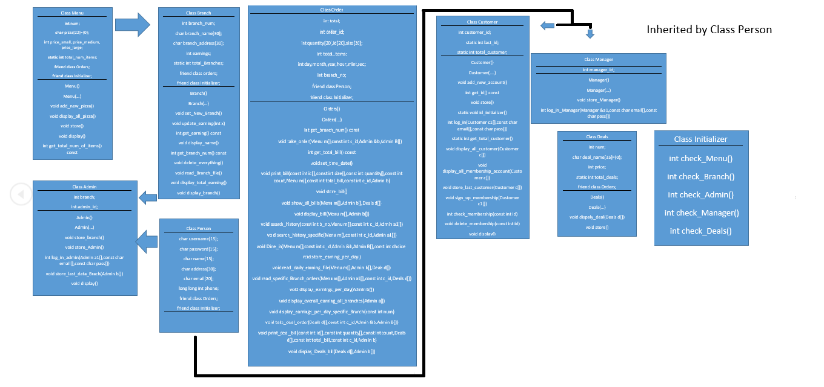

**Class Menu:** This class object will store all the information about a pizza e.g. (its name, price, serial no) etc. In our project we have created an array of object of this class so we can create a menu and store multiple items (pizzas).

**Class Deals:** This class is created for mid-night deals; its work is simple. It stores name and price for a deal.

**Class Branch:** This class object stores all the information about a particular branch. Here we have also done inheritance of class Menu, if in case we want different menus for different branches.

**Class Person:** This class is an abstract class created to be inherited in other classes to provide basic definition of a person.

**Class Customer:** This class object will store all the data about a person who orders online by signing up and when a customer signs up for membership.

**Class Admin:** This class object will store all the data about an admin of a branch. This class is inherited by two classes, first from person and second from Branch because different branches will have different admins.

**Class Manager:** This class object will store all the data about a manager. This class is inherited by class person. This class is friend class of all classes. Manager have a special access over the all other classes.

**Class Orders:** This is the main class where all the main processing is done. The main work of this class is to take order and store that data of order and the data of the customer by whom the order is made.

**Class Initializer:** This class is made to store the old data back in different arrays which is in files.

**4. Link to source**

* <https://github.com/Areez0362/OOP-Project-Pizza-Hut-Online-System-with-Membership.git>

**5. Future work**

The future work that could be done on this project is to implement this all logic with GUI. All different branches would have different menus and we will add items other than Pizzas. More functions for manager like to add a new branch, new admin, replace an admin. More Functions for Admin like to add more items to menu or remove an item from menu.